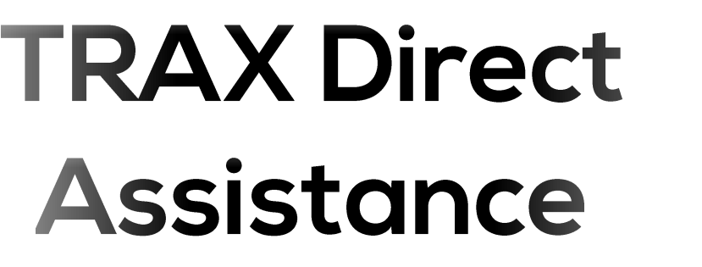

Version 1.0

**Copyright © 1997-2019 by Trax and its subsidiaries. All rights reserved.**

**eMRO® and logo are trademarks registered in the U.S. Patent and Trademark Office.**

This manual may not be copied, photocopied, reproduced, translated, or converted to any electronic or machine-readable form, in whole or in part, without prior written approval from Trax.

Trax reserves the right to make improvements, changes, and/or deletions to any of the products and functionalities depicted or described herein at any time based on evolving industry, customer, and company business standards. As such, the content provided herein may be subject to periodic edits that may therefore render prior documents and functionalities invalid. This document is designed as a reference guide only and is one of a larger collection of system documents available on iCentral.

✈



Contents

1. Introduction………………………………………………………………………………………………………………………………………………..3

2 What is ScreenConnect? 3

1. ScreenConnect…………………………………………………………………………………………………………………………………………….3

3.1 Jump Box ........................................................................................................................................................ 3

1. Whitelisting ScreenConnect…………………………………………………………………………………………………………………………4

4.1 Allow ConnectWise Control (ScreenConnect) Access through your Firewall/Proxy 4

4.2 Confirm Connectivity to Relay Server…………………………………………………………………………………………………. 4

4.3 Using Telnet to Confirm Connectivity…………………………………………………………………………………………………. 7

4.4 Document Revision History……………………………………………..………………………………………………………………….8



Copyright © 1997-2019 by Trax & its subsidiaries. eMRO® and logo are trademarks registered in the U.S. Patent and Trademark Office. All rights reserved. This manual may not be copied, photocopied, reproduced, translated, or converted to any electronic or machine-readable form, in whole or in part, without prior written approval from TRAX. Confidential and Proprietary Information.

✈



This manual outlines the use of ScreenConnect and how it can be implemented to provide better support.



Connectwise ScreenConnect is a remote support software that may be used to connect to any machine enabled to do so via agent and support session.



Trax officially uses ScreenConnect to deliver its remote support. With that said, we will provide an Agent installer laced with the proper build to add to our Relay Service. The installation is quick and easy. Following installation, we will be able to see the machine available.



A Jump Box is a computer on the network that allows TRAX to enter your environment at any time. What we will require from this machine:

1-Administrative Credentials to this machine--to use the agent.

2- Access to the environments that you would like us to support

TRAX will provide a link that will enable you to download and install the Agent to install on your host machine. Once the wizard has finished the installation process, it will automatically connect to our relay server at which point, it is ready for support.



Copyright © 1997-2019 by Trax & its subsidiaries. eMRO® and logo are trademarks registered in the U.S. Patent and Trademark Office. All rights reserved. This manual may not be copied, photocopied, reproduced, translated, or converted to any electronic or machine-readable form, in whole or in part, without prior written approval from TRAX. Confidential and Proprietary Information.

✈



ScreenConnect uses TCP port 443 to connect to:

instance-bvw0ej-relay.screenconnect.com, and

trax.screenconnect.com

For that reason, both of those should be whitelisted.

See **Section 4.3** for information regarding advanced firewall detection applications. For these advanced types of firewalls, you must also “allow” the ScreenConnect Application to access to the Internet addresses specified under **Section 4.1.** You may also need to verify application filters on your proxy, antivirus, or if using SSL is decryption. ScreenConnect will not connect unless the SSL connection is secure.

For testing purposes, you can use the IP address provided below (at the time of this document update). Equally important, you do not want to whitelist only this IP as ScreenConnect may routinely change this IP resulting in recurring issues when changed. Also, ping requests are blocked by ScreenConnect security policy.



Go to your Control Panel and select Programs & Features

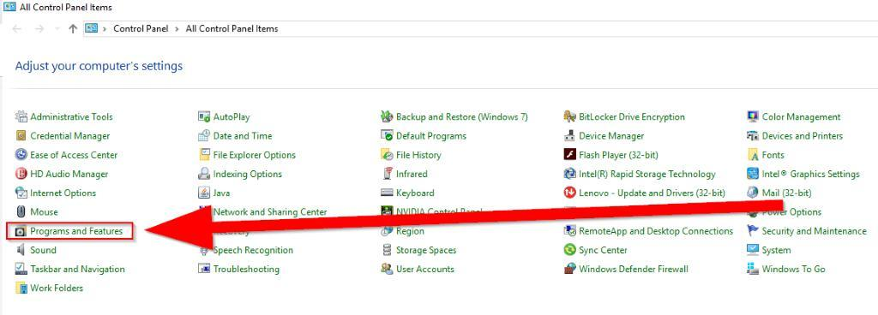

Copyright © 1997-2019 by Trax & its subsidiaries. eMRO® and logo are trademarks registered in the U.S. Patent and Trademark Office. All rights reserved. This manual may not be copied, photocopied, reproduced, translated, or converted to any electronic or machine-readable form, in whole or in part, without prior written approval from TRAX. Confidential and Proprietary Information.

✈



Click on “Turn Windows Features on or off”

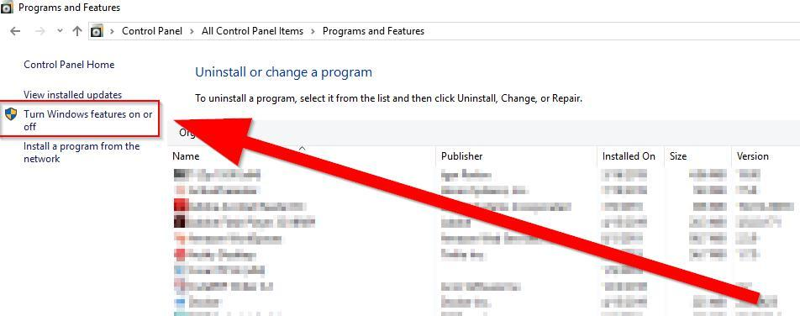

Enable Telnet Client

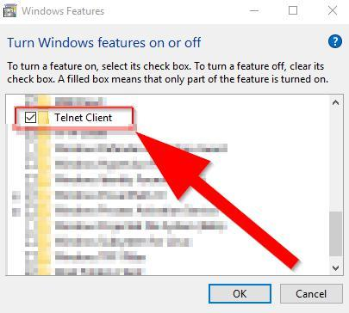

Copyright © 1997-2019 by Trax & its subsidiaries. eMRO® and logo are trademarks registered in the U.S. Patent and Trademark Office. All rights reserved. This manual may not be copied, photocopied, reproduced, translated, or converted to any electronic or machine-readable form, in whole or in part, without prior written approval from TRAX. Confidential and Proprietary Information.

✈



The wizard will appear and when completed, it will restart the system.

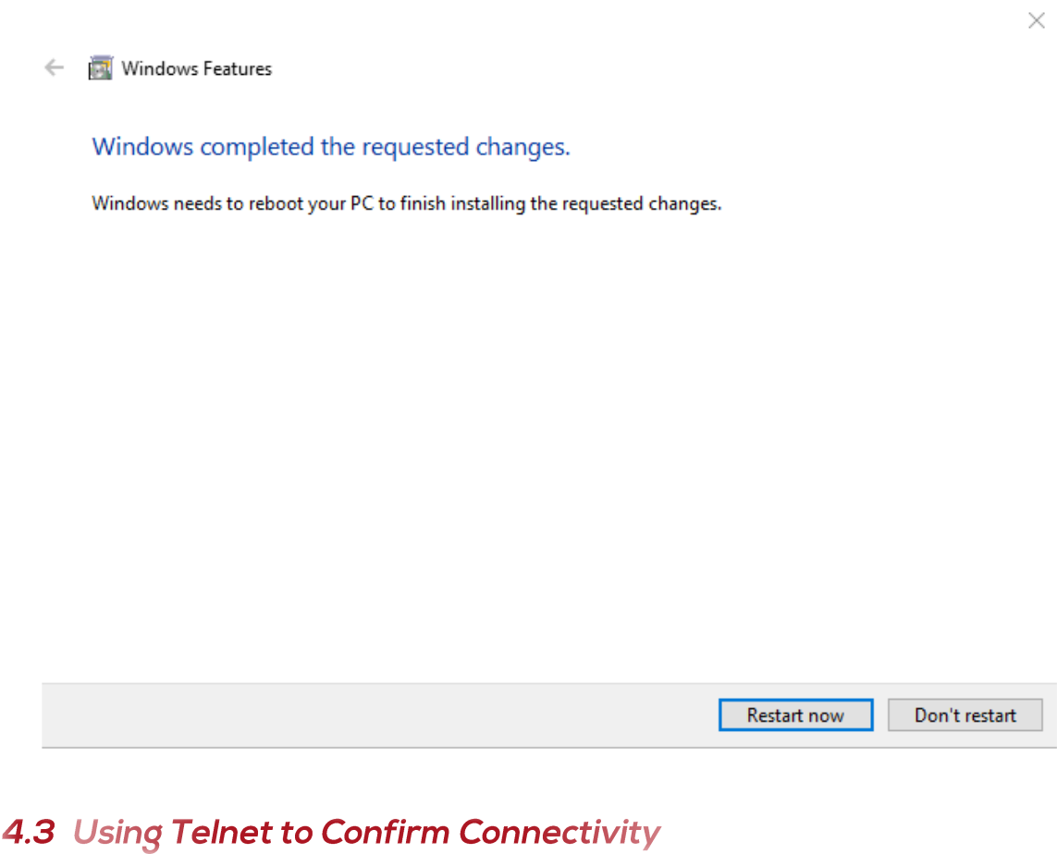

Open your command prompt and type ‘telnet instance-bvw0ej-relay.screenconnect.com 443



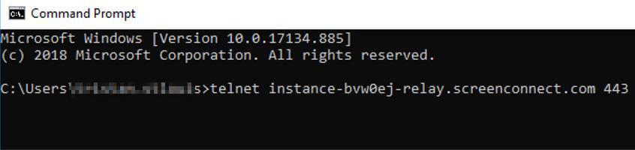

Copyright © 1997-2019 by Trax & its subsidiaries. eMRO® and logo are trademarks registered in the U.S. Patent and Trademark Office. All rights reserved. This manual may not be copied, photocopied, reproduced, translated, or converted to any electronic or machine-readable form, in whole or in part, without prior written approval from TRAX. Confidential and Proprietary Information.

✈



This command confirms the connection, or lack thereof.

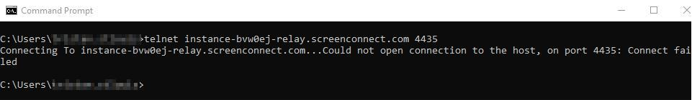

In case it fails, we must check on Antivirus Utility Settings & Computer Policies

Known Antivirus Programs and spyware protection programs that block ScreenConnect by default in their filters are:

|  | Windows Smartscreen |  | Symantec |
| --- | --- | --- | --- |
|  | Panda ActiveDefense |  | Trend Micro |
|  | Kaspersky |  | Webroot |
|  | Avast |  | Windows Defender |

AVG

|  | Bitdefender | Firewall App Filters | |
| --- | --- | --- | --- |
|  | ESET |  | FortiGuard |
|  | McAfee |  | Palo Alto |
|  | Norton Antivirus |  | SonicWall |



Copyright © 1997-2019 by Trax & its subsidiaries. eMRO® and logo are trademarks registered in the U.S. Patent and Trademark Office. All rights reserved. This manual may not be copied, photocopied, reproduced, translated, or converted to any electronic or machine-readable form, in whole or in part, without prior written approval from TRAX. Confidential and Proprietary Information.

✈





| Revision | Date | Revised Content | Revised By |
| --- | --- | --- | --- |
|  |  |  |  |
| 1.0 | 10/04/2019 | Initial Draft | Mauricio Venzais |
|  |  |  |  |
| 1.1 |  |  |  |
|  |  |  |  |
| 1.2 |  |  |  |
|  |  |  |  |
| 1.3 |  |  |  |
|  |  |  |  |
| 1.4 |  |  |  |
|  |  |  |  |
| 1.5 |  |  |  |
|  |  |  |  |
|  |  |  |  |